**First Grade Supply List: 2025**

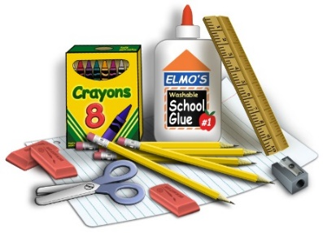

*1 backpack

*Water bottle (with a lid that closes tightly so it won’t spill)

*Headphones (please label with child’s name)

For class to share:

*2 boxes of tissue

*2 boxes of Crayola crayons

*6 glue sticks

*2 dark, dry erase markers (no yellow)

*12 #2 pencils (Ticonderoga tend to work best. Please don’t send any

pencils that have plastic on them. Pre-sharpened is appreciated).

*3 pink or gummy erasers

*1 box of colored pencils (24 count)

*2 medium Sharpie permanent markers

*2 packages pencil top erasers

*2 thin highlighters

*$25.00 classroom fund (check payable to Verdi) for classroom

magazine, science supplies, math materials and literacy resources.

We are looking forward to a fantastic first grade year!

Thank you,

Mrs. Atkinson, Mrs. Steele and Mrs. Worthen